NOVEMBER 4th ELECTION DAY
You have to be at least 18 years old to vote, you must be a United States citizen, and you must be registered to vote.
The president has to be born in the United States and be at least 35 years old. He /she can only be President for eight years (that's two four-year terms.)
Each state has a certain number of electoral votes. The more people that live in your state-the more electoral votes your state gets. (That’s why candidates spend a lot of time in California, New York, and Texas) In 48 of the states, the candidate that gets the most votes gets all the electoral votes for that state. The first candidate to win 270 electoral votes becomes the President!
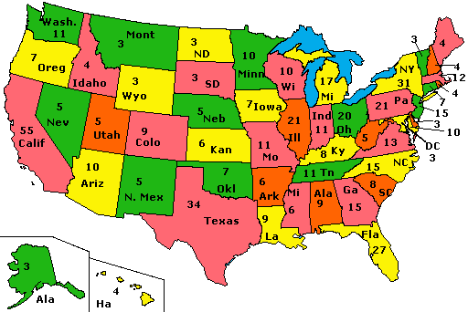

NOVEMBER 4th ELECTION DAY
You have to be at least 18 years old to vote, you must be a United States citizen, and you must be registered to vote.
The president has to be born in the United States and be at least 35 years old. He /she can only be President for eight years (that's two four-year terms.)
Each state has a certain number of electoral votes. The more people that live in your state-the more electoral votes your state gets. (That’s why candidates spend a lot of time in California, New York, and Texas) In 48 of the states, the candidate that gets the most votes gets all the electoral votes for that state. The first candidate to win 270 electoral votes becomes the President!

