Welcome in Times Square!
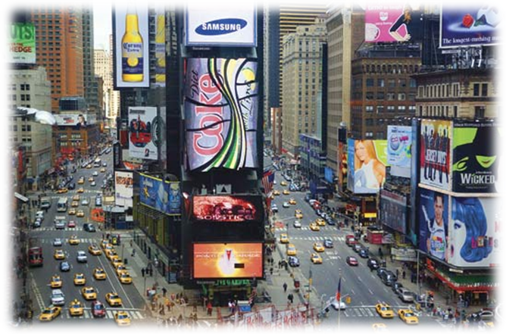
Times Square is a very popular place in New York. They are here all the most important theaters of this city.
It is located in Manhattan, at the crossing of Broadway and 42nd street, between 6th and 9th street. About 365 000 people walk through this place every day.
It has been created in 1904 and the name “Times Square” comes from the building of the newspaper “New York Times” who is located there.
The New York Times building is inspired by the campanile of Florence, in Italy.
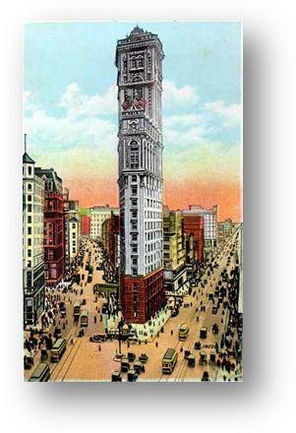
New York Times Building in 1904

Jules Oïffer, 4e D

